Big Data Fundamentals
- What is Big Data?
Big Data refers to extremely large, complex, & rapidly growing datasets that cannot be effectively captured, stored, processed, & analyzed using the traditional/conventional database management systems & conventional computing methods.
Big Data is not defined solely by size. It also includes data that is:
- Generated at very high speed.
- Comes from multiple sources & formats.
- Requires advanced processing techniques.
- Demands scalable storage & computing infrastructure.
Examples of Big Data sources include:
- Social media platforms
- E-Commerce websites
- Banking transactions
- IoT sensors
- Mobile applications
- Healthcare systems
- Telecommunication networks
Organization leverages Big Data to:
- Improve decision making
- Understand customer behavior
- Detect fraud
- Optimize business operations
- Build machine learning & AI solutions
- Enable predictive analytics
- 5 V's of Big Data
The characteristics of Big Data are commonly explained using the 5V’s.
- Volume – refers to the enormous quantity of data generated daily.
- Velocity – represents the speed at which data is generated, collected, & processed.
- Variety – refers to different forms & structure of data.
- Veracity – refers to the quality, reliability, & accuracy of data.
- Value – represents the business benefits extracted from data.
- Traditional vs Distributed Computing
Aspect | Traditional Computing | Distributed Computing
Processing | Single machine | Multiple machines
Scalability | Vertical | Horizontal
Cost | Higher for large expansion | More economical
Fault Tolerance | Low | High
Performance | Limited | High
Data Size | Small to medium | Very large datasets

- Challenges of large-scale data processing
- Storage Challenges
- Processing Challenges
- Scalability Challenges
- Data Integration Challenges
- Fault Tolerance Challenges
- Security & Privacy Challenges
- Real Time Procesing Chanlanges
- Hadoop Ecosystem Overview
What is Hadoop?
It is an open-source framework designed for distributed storage & distributed processing of large datasets across clusters of community hardware.
Core Goals Of Hadoop
- Scalability
- Reliability
- Fault Tolerance
- Cost efficiency
Hadoop Ecosystem Components
- HDFS
- MapReduce
- YARN (Yet Another Resource Negotiator)
- Hive
- Pig
- HBase
- Sqoop
- Flume
- Oozie
Benefits of Hadoop Ecosystem
- Fault tolerance through replication
- Massive scalability
- Cost-effective storage
- Distributed processing capabilities
- Support for structured & unstructured data
- Spark Ecosystem Overview
What is Apache Spark?
Apache Spark is fast, distributed computing framework designed for large-scale data processing & analytics.
Unlike Hadoop MapReduce, Spark performs much of its computation in memory, significantly improving performance.
Key features of Spark
- In-memory computation
- High-speed processing
- Fault tolerance
- Scalability
- Support for batch & streaming workloads
- Rich APIs & libraries
Spark Ecosystem Components
- Spark Core
- Spark SQL
- Spark Streaming
- MLlib
- GraphX

Why Spark Is Popular?
- Faster than MapReduce for many workloads
- Supports multiple programming languages
- Unified processing platform
- Suitable for both batch & streaming analytics
Apache Spark Architecture
- Spark Components
- Driver Program
- Cluster Manager
- Worker Nodes
- Executors
- Tasks
- Jobs & Stages
- Spark Cluster Architecture
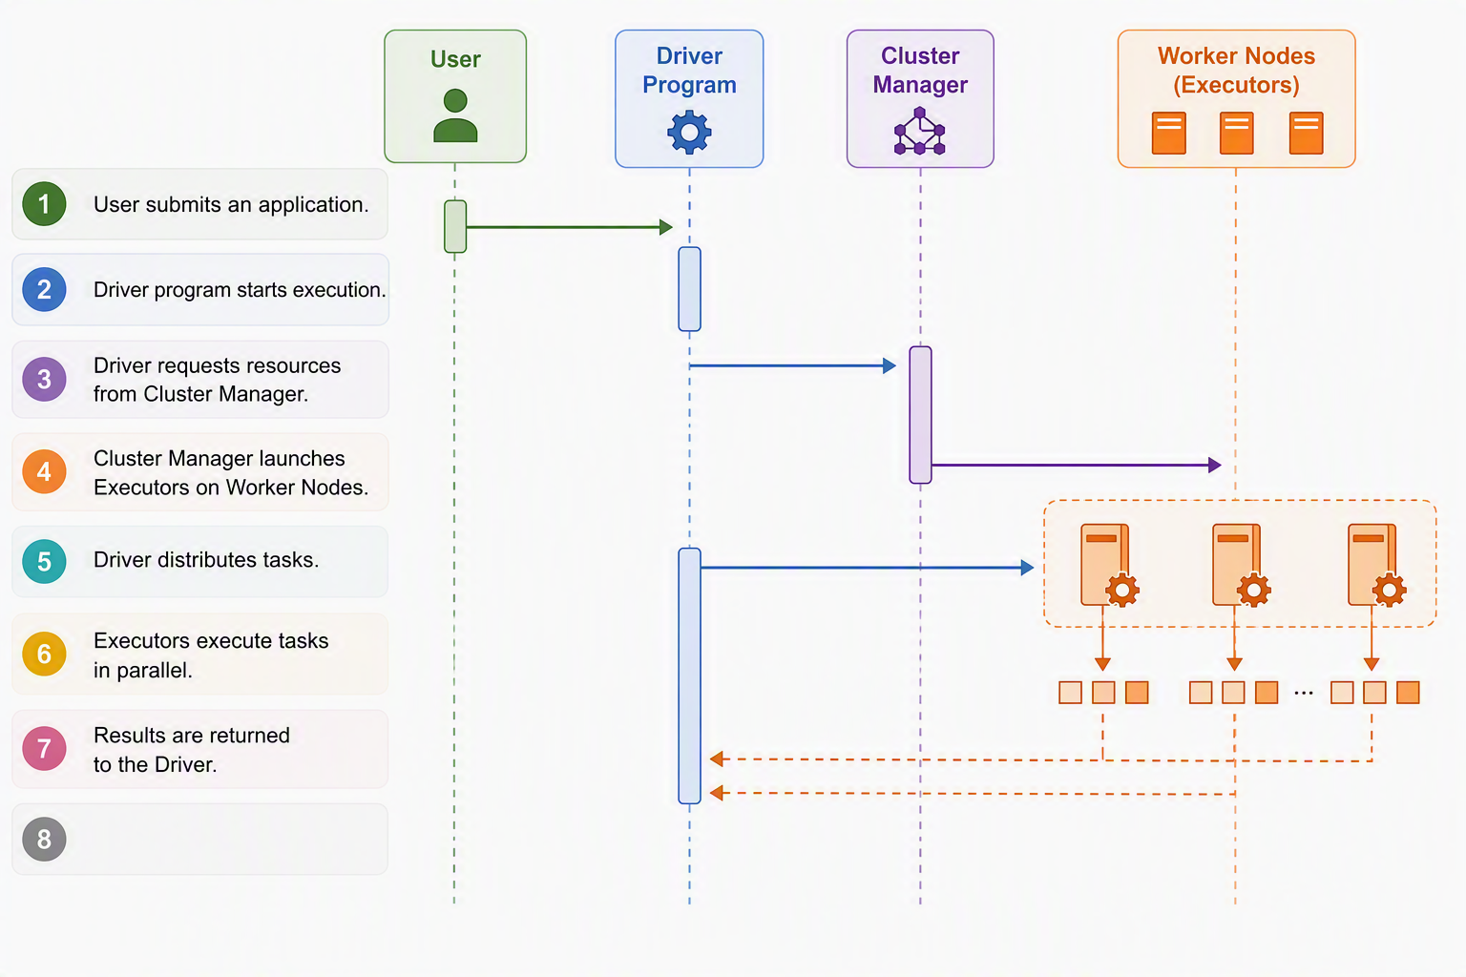

Spark Modes
Spark
- Local Mode
- Standalone Mode
- YARN
- Kubernetes
Demo
- Software Requirements
  - Java JDK 8/11/17
  - Python 3.8+
  - Apache Spark
  - pip
- Install Spark
- Configure PySpark
- Create first Spark Session
- Execute Spark shell commands

